**How to Run “Watercolour Converter” Locally:**

1. If you do not have it already, download [pip](https://pip.pypa.io/en/stable/installing/)
2. Use your favourite terminal to navigate into this project’s backend and make sure that the following folders and files exist (other folders may exist but they are not as important)
   1. uploads
   2. results
   3. images
   4. templates
   5. app.py
   6. model.pkl

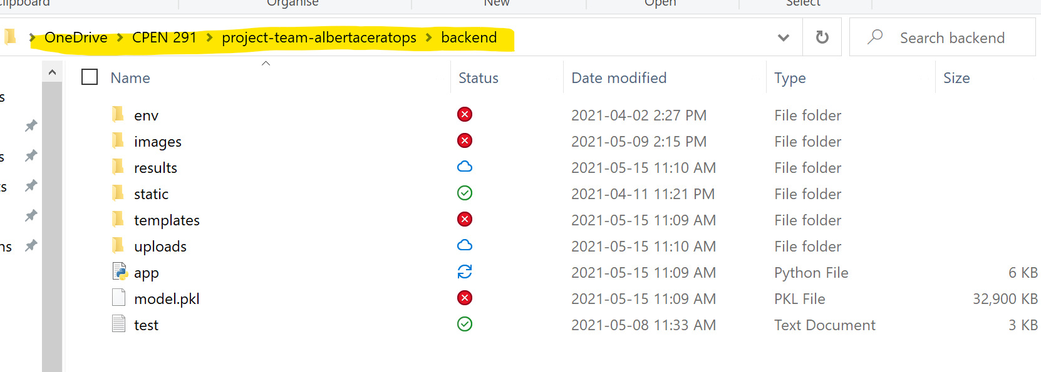

1. Run the following commands (in order)
   1. py -3 -m venv venv
   2. pip install Flask
   3. pip install flask-dropzone
   4. python app.py
2. Once you run 3d. something like the following picture should show up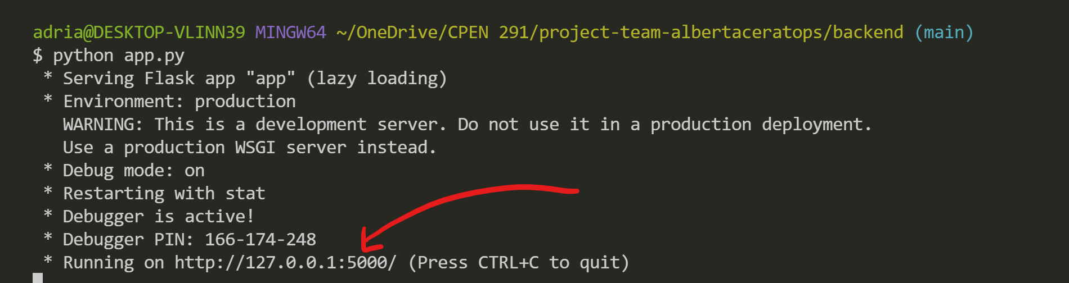

Click on the link to open the website 😊

If you have any issues, feel free to contact me at adriana.e.castro@outlook.com